# Experiment 3: Linux File Manipulation and System Manipulation I

### Name: Tushita Sharma Roll No.: 590029121 Date: 2025-09-23

### Aim:

* To practice Linux file manipulation commands like touch, cp, mv, rm, cat, less, head, tail.
* To explore file permissions and ownership with ls -l, chmod, chown, and chgrp.
* To search and filter files using find and grep.
* To understand archiving and compression with tar, gzip, and gunzip.
* To create and manage links (ln) for both hard and symbolic links.

### Requirements

* A Linux machine with bash shell (Ubuntu/Fedora/other).
* User privileges to create, modify, and delete files and directories.
* Access to system utilities like tar, gzip, grep, and find.

## Theory

Linux file management involves creating, copying, moving, removing, and viewing files. File permissions and ownership ensure secure access control. Searching and filtering tools like grep and find help locate information efficiently. Archiving with tar and compression with gzip reduce storage usage and simplify file transfer. Links (ln) allow multiple references to the same file data (hard links) or path references (symbolic links).

## Procedure & Observations

## Exercise 1: Creating and Managing Files

### Task Statement:

Create files and manage timestamps using touch.

### Command(s):

touch newfile.txt  
touch file1.txt file2.txt file3.txt  
touch -t 202401151430 dated_file.txt

### Output:

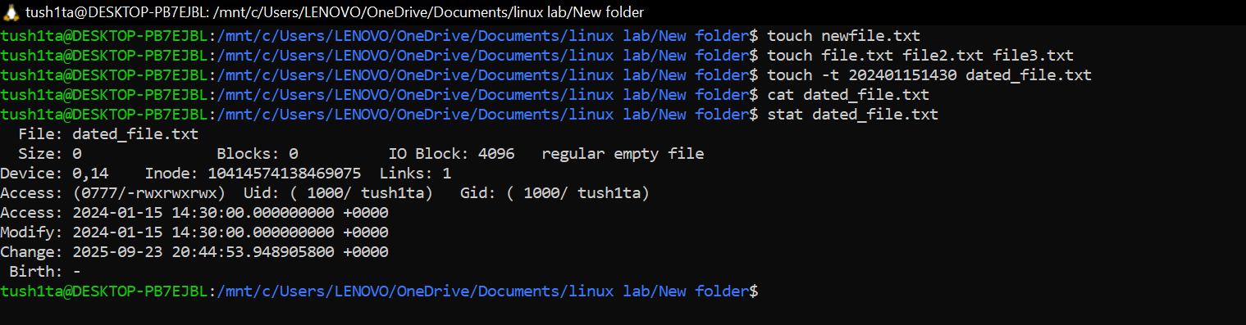

## Exercise 2: Copying, Moving, and Deleting Files

### Task Statement:

Use cp, mv, and rm to copy, rename, move, and delete files and directories.

### Command(s):

cp document.txt backup_document.txt  
mv oldname.txt newname.txt  
rm unwanted_file.txt  
rm -r old_directory/

Output:

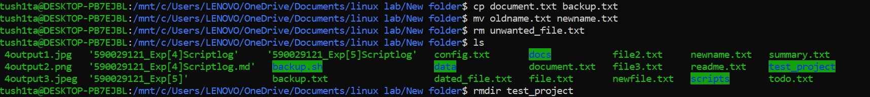

## Exercise 3: Viewing File Contents

### Task Statement:

Display file contents using cat, less, head, and tail.

### Command(s):

cat filename.txt  
less /var/log/syslog  
head -n 5 filename.txt  
tail -n 20 filename.txt  
tail -f /var/log/syslog

Output:

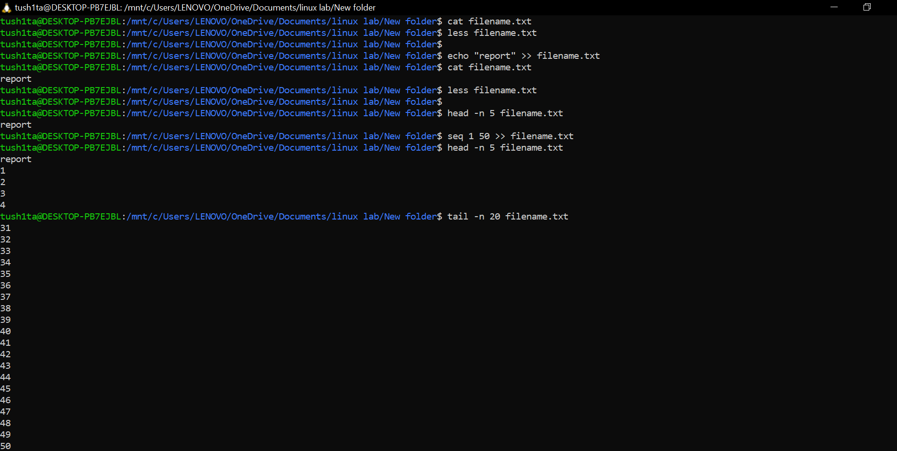

## Exercise 4: File Permissions and Ownership

Task Statement:

Explore file permissions and ownership with ls -l, chmod, chown, and chgrp.

### Command(s):

ls -l  
chmod 755 script.sh  
chmod u+x script.sh  
sudo chown newuser:newgroup file.txt  
chgrp developers project.txt

### Output:

## Exercise 5: File Searching with find

## Task Statement:

Search files by name, type, size, and permissions using find.

### Command(s):

find -name "*.txt"  
find -size -5k  
find -perm 777

### Output:

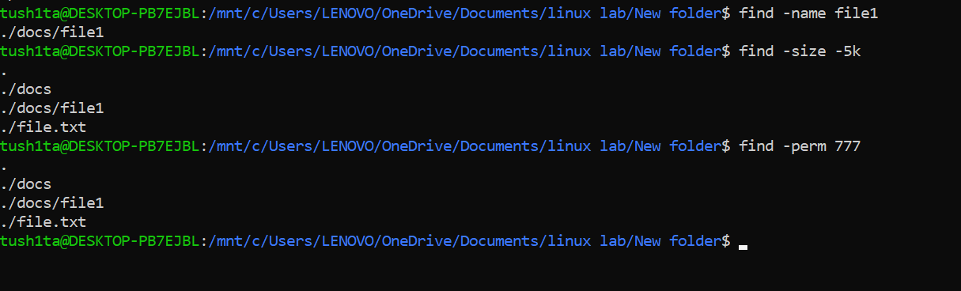

### Exercise 6: Pattern Searching with grep

### Task Statement:

Search for patterns in files using grep.

### Command(s):

grep "error" /var/log/syslog  
grep -i "Error" logfile.txt  
grep -r "function" ~/code/  
grep -n "TODO" *.txt

### Output:

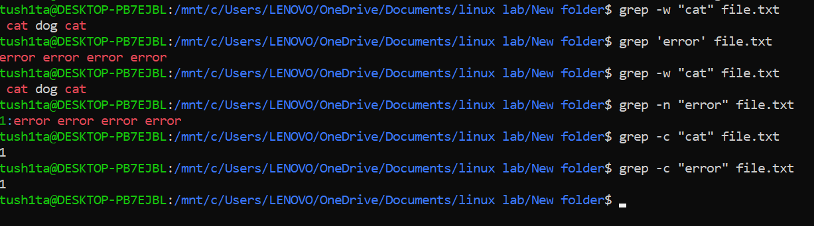

## Exercise 7: Archiving and Compression

### Task Statement:

Create and extract archives using tar, compress and decompress with gzip/gunzip.

### Command(s):

tar -czf backup.tar.gz /home/user/documents  
tar -xzf backup.tar.gz -C /restore/  
gzip largefile.txt  
gunzip largefile.txt.gz

### Output:

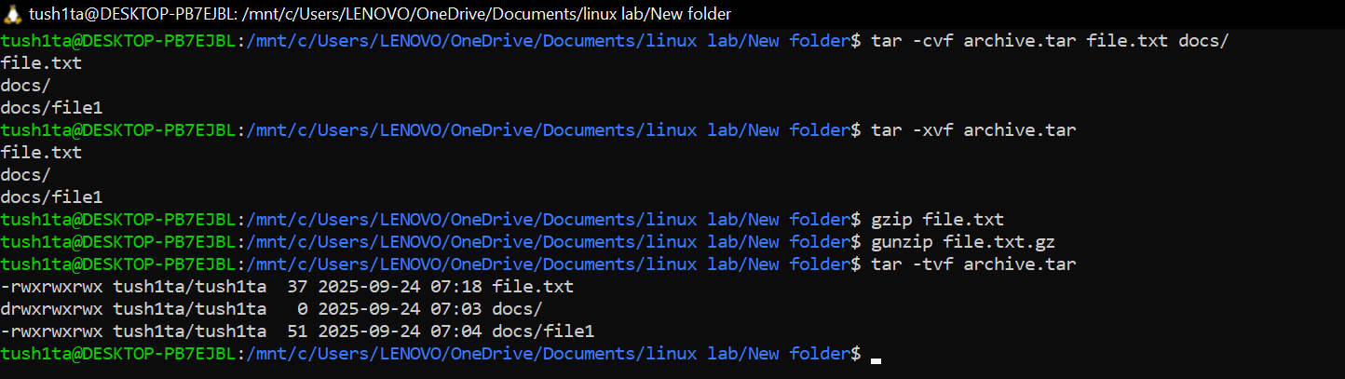

## Exercise 8: Creating Links

### Task Statement:

Create and test hard and symbolic links using ln.

### Command(s):

echo "Hello" > original.txt  
ln original.txt hardlink.txt  
ln -s original.txt symlink.txt  
ls -li original.txt hardlink.txt symlink.txt

### Output:

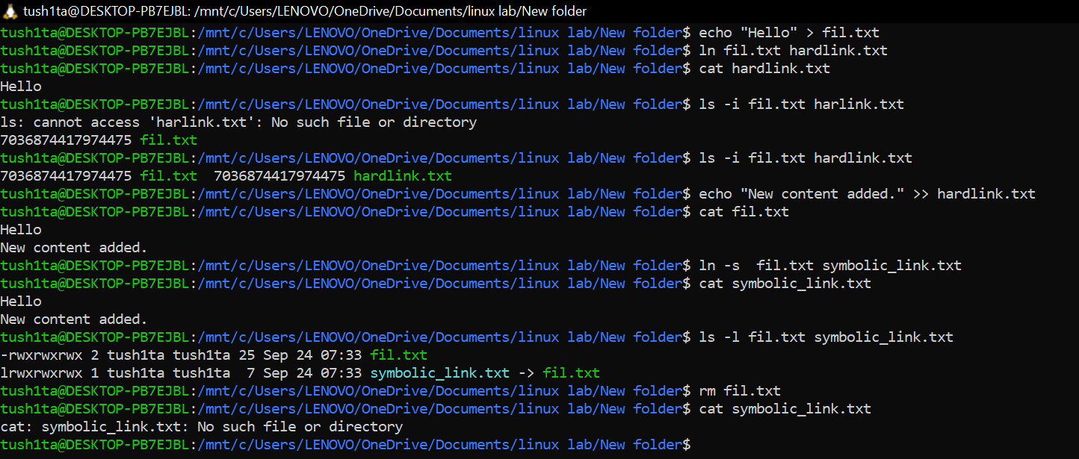

## Result

* Successfully created, copied, moved, and deleted files.
* Practiced viewing file contents and monitoring logs.
* Explored file permissions and ownership management.
* Used find and grep to locate and filter data.
* Created archives and compressed files.
* Demonstrated both hard and symbolic links.

## Challenges Faced & Learning Outcomes

* Challenge 1: Managing files and directories effectively without accidentally overwriting or deleting important data.
* Challenge 2: Remembering numeric vs symbolic permissions in chmod. Fixed through repeated practice.

### Learning:

* Gained hands-on experience with essential Linux file manipulation commands (cp, mv, rm, cat, touch, nano/vim, etc.).
* Gained practical skills with file manipulation and permission commands.
* Learned how to efficiently search files and patterns in Linux.
* Understood how to archive and compress files for better storage management.
* Understood differences between hard and symbolic links.

## Conclusion

This experiment helped me understand and apply basic Linux file and system manipulation commands. I learned to manage files, directories, and permissions effectively, improving my confidence in using the Linux environment.